UNIT 11 HW

1. From Problem 26, Chapter 8:

The Metabolic data set has the average mass, metabolic rate, and average lifespan of 95 different species of mammals. Kleiber’s Law states that the metabolic rate of an animal species, on average, is proportional to its mass raised to the power ¾. Judge the adequacy of this theory with these data. Ultimately, for this problem, we want to find the best model. (At this point, you will limit the analysis to the two variables under study, though the data set has more variables.) In the current data set, assume that mass has not yet been raised to the power ¾.

* Use alpha = 0.05.
* Use **SAS** for this problem.
* Include **relevant** code and output. Make sure you directly answer the questions. Do NOT assume the answer is obvious from the output.

Specifically, provide/answer the following:

* + 1. Judging by a scatterplot alone, does it seem reasonable that the metabolic rate of an animal species, on average, is proportional to its mass raised to the power of ¾? (Recall that if some variable y is proportional to the variable x, then (with nonzero m) is a well-fitting model.) In other words, does the data (metabolic rate, mass3/4) reasonably fall along a straight (nonhorizontal) line and nearly pass through the origin?

SAS Code

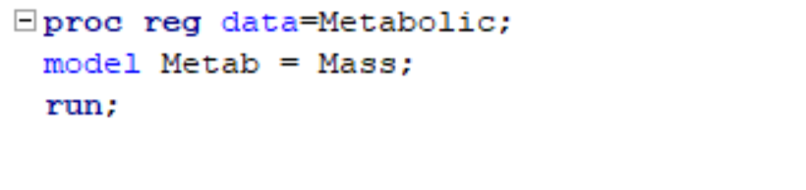

Judging from the code it does not seem reasonable that metabolic rate of an animal on average is proportional to its mass raised. As you can see below that Metab and Mass compared do not have linear relationship and seem to have cluster on 0 residual. There will need to a log transformation to see if we can bring normality to the data.

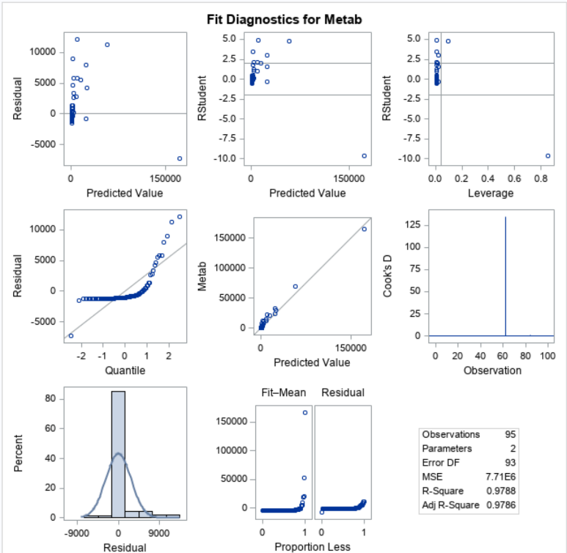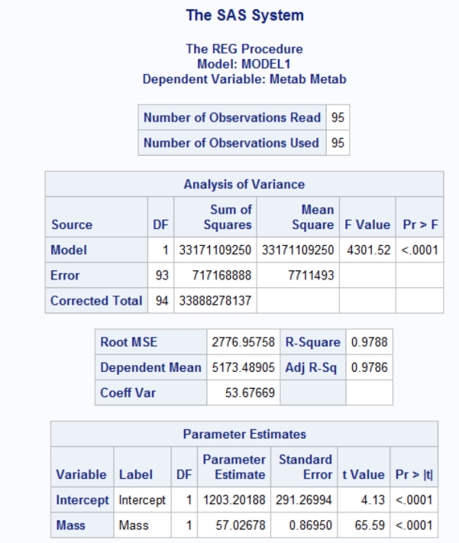

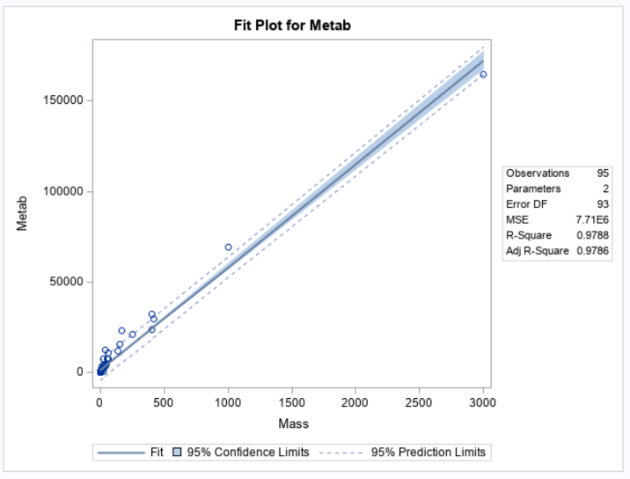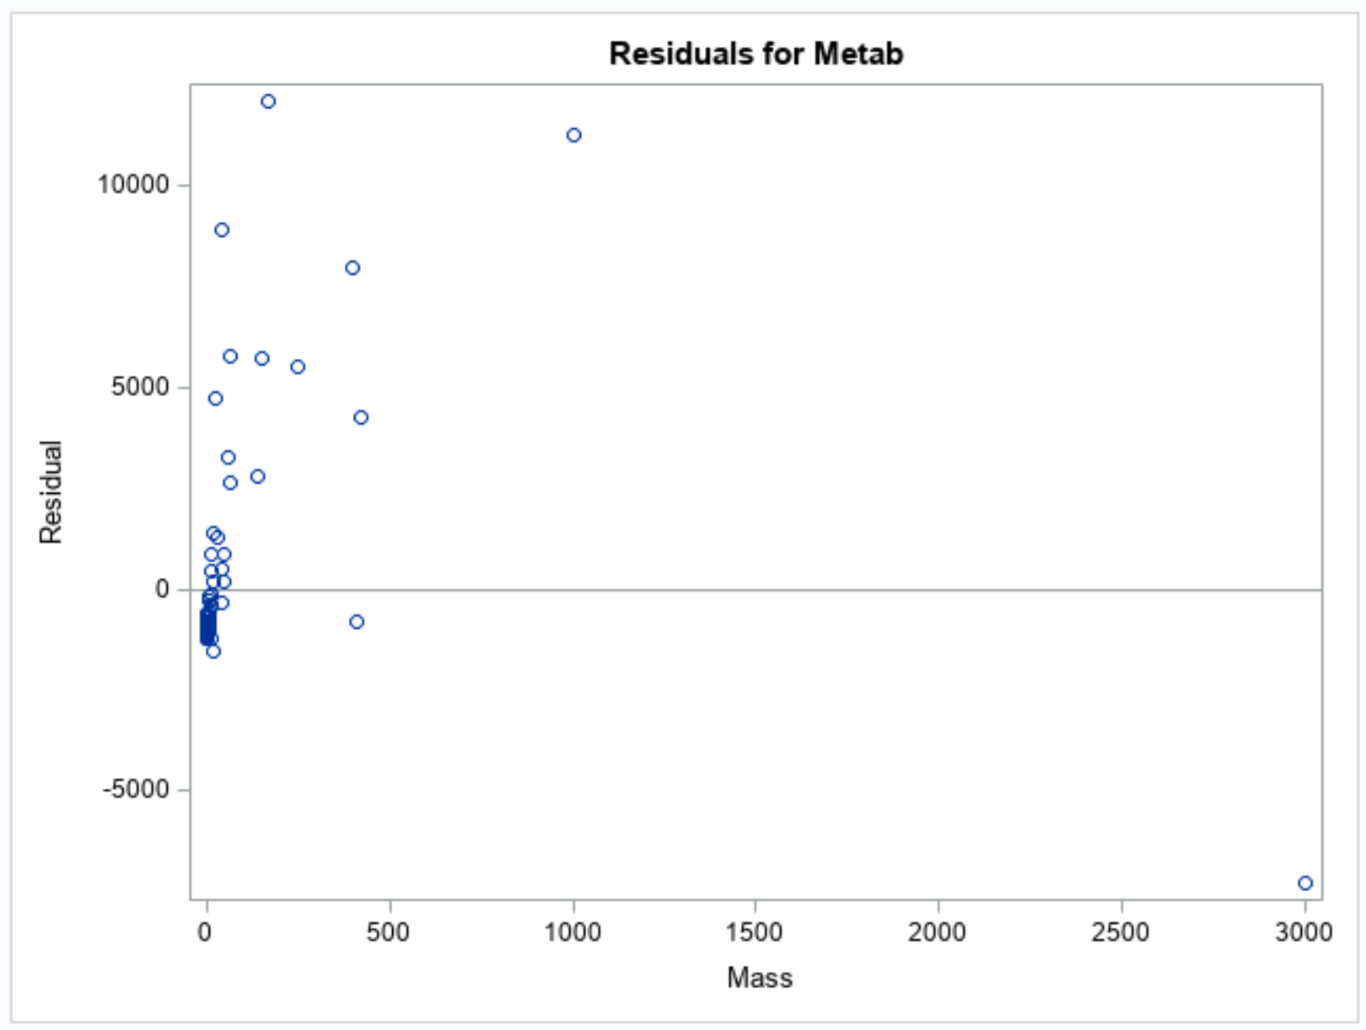

* + 1. We want to find the “best” model to predict metabolic rate from mass3/4 **and** make appropriate statistical inferences. Therefore, address all the assumptions prior to the analysis (using mass3/4). If the assumptions are not met, handle the data appropriately. If a transformation is used to satisfy the assumptions, address the assumptions again to ensure that the transformation is logical, and carry out your analysis on your newly transformed data. For example, you should include a scatter plot for the original data AND transformed data, etc. (Hint: if a transformation is necessary, try one of the transformations discussed in class first.) Either way, keep the “mass3/4” in the model; do not go back to regular “mass,” although mass3/4 may be transformed if it makes sense for the assumptions. At minimum, provide and interpret the following elements to address assumptions FOR THE ORIGINAL DATA AND ANY TRANSFORMED DATA (IF you use a transformation). You may include more graphs if you find them useful.

1. A scatterplot with the following included on the graph: regression line, confidence intervals of the regression line, and prediction intervals of the regression line.

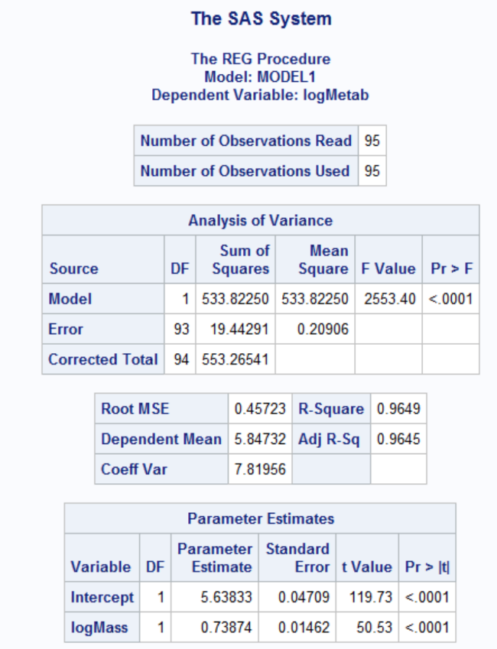

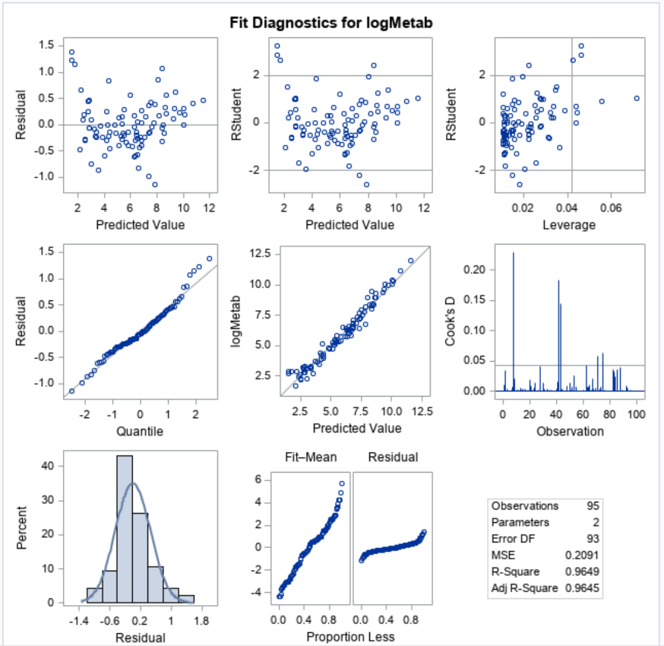

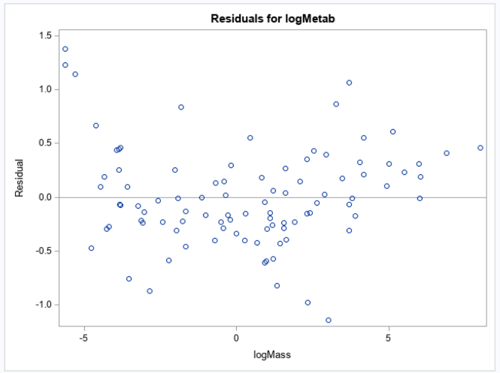

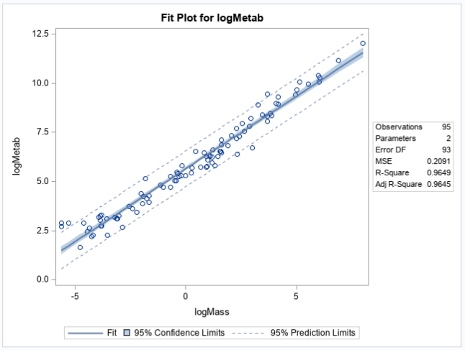

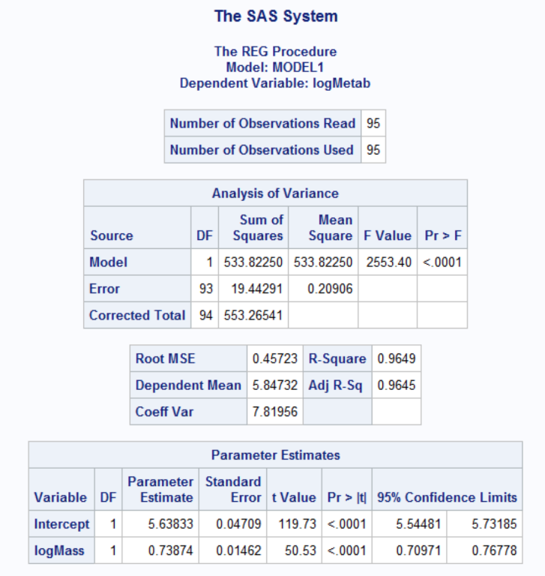

ii. A scatterplot of residuals.

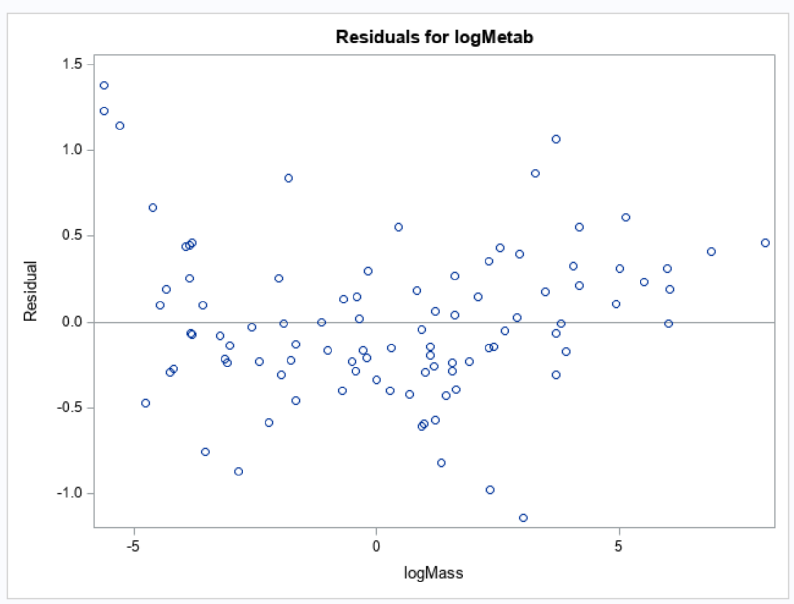

iii. A histogram of residuals with the normal distribution superimposed.

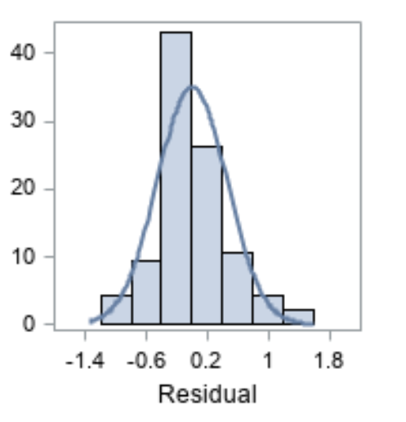

iv. A discussion supporting the use of the model you chose (support that the assumptions are met).

* + 1. Once a reasonable model is found (possibly using a transformation), provide a table showing the t-statistics and p-values for the significance of the regression parameters .
    2. The estimated regression equation. Make sure the dependent variable is noted as the predicted value or predicted mean value, not just the dependent variable.
    3. Interpretation of the model, paying special attention if you used a transformation (hint!). That is, interpret the slope as well as the **confidence interval**.
    4. A measure of the proportion of variation in the response that is accounted for by the explanatory variable. Interpret this measure clearly.

1. From Problem 29, Chapter 8:

The autism data show the prevalence of autism per 10,000 ten-year-old children in the United States in each of five years. Analyze the data to describe the change in the distribution of autism prevalence per year during this time period.

* Use alpha = 0.05.
* Use **R** for this problem.
* Include **relevant** code and output. Make sure you directly answer the questions. Do NOT assume the answer is obvious in the output.

Specifically, provide/answer the following:

* + 1. Address all the assumptions for a linear regression model prior to the analysis. If the assumptions are not met, handle the data appropriately. If a transformation is used, address the assumptions again with the transformed data to ensure that the transformation is logical. The questions below should reflect this. For example, you should include a scatter plot for the original data AND transformed data, etc. (Hint: if a transformation is necessary, try one of the transformations discussed in class first.) At minimum, provide and interpret the following elements to address assumptions FOR THE ORIGINAL DATA AND ANY TRANSFORMED DATA (IF you use a transformation). You may include more graphs if you find them useful.

1. A scatterplot with the following included on the graph: regression line, confidence intervals of the regression line, and prediction intervals of the regression line.

ii. A scatterplot of residuals.

iii. A histogram of residuals with the normal distribution superimposed.

iv. A discussion supporting the use of the model you chose (support that the assumptions are met).

* 1. Once a reasonable model is found (possibly using a transformation), provide a table showing the t-statistics and p-values for the significance of the regression parameters .
  2. The estimate regression equation. Make sure the dependent variable is noted as the predicted value or predicted mean value, not just the dependent variable.
  3. Interpretation of the model, paying special attention if you used a transformation (hint!). That is, interpret the slope as well as the **confidence interval**.
  4. A measure of the proportion of variation in the response that is accounted for by the explanatory variable. Interpret this measure clearly.